Breakfast

The Bakery
- Cookies….0.50 each
- Daily Bagels….2.5
- Daily Muffins….3
- Brownies….3

Ask for our daily baked goods & sweet treats

The Classics
- Two Eggs & Cheese….3.5
- Bacon, Two Eggs, & Cheese….4
- Sausage, Two Eggs, & Cheese….4
- Ham, Two Eggs, & Cheese….4
- Steak, Two Eggs, & Cheese….4.5
- French Toast….7
- Home Fries….3.5

All breakfast sandwiches served on a Portuguese roll. Make it on a Bagel….1.5

B’s Omelette Sandwiches

- South of The Border….7
Ham, Pico De Gallo, Avocado, Cheddar Cheese

- Meat Head….7.5
Bacon, Ham, Sausage, Onion, Pepper Jack Cheese

- The Greek….7
Spinach, Roasted Red Peppers, Mushrooms, Olives, Onion, Feta Cheese

- The Italian….7
Roasted Tomatoes, Mozzarella, Sausage, Italian Seasoning
Lunch/Dinner

Sandwiches

Add French Fries, Potato Salad, or Coleslaw….3.5

- Southern Comfort….11
Fried Pork Tenderloin, Sauteed Spinach, Caramelized Onions, Blue Cheese Crumbles, Homemade Apple Butter

- Tom the Turkey….11
House Roasted Turkey Breast Sliced Over Our Holiday Stuffing, Arugula, Roasted Tomatoes & Cranberry Sauce

- Billy’s Philly….12
Shaved Steak, Roasted Red Peppers, Grilled Onions and Mushrooms, American Cheese

- Sinatra….11
Grilled Chicken Breast, Mozzarella, Roasted Red Peppers, Sauteed Spinach, Pesto, & Balsamic Glaze

- Pastrami or Turkey Reuben….10
Thin Sliced Pastrami or Turkey, Swiss Cheese, Sauerkraut, Caramelized Onions, Thousand Island

- Buffalo Soldier….10
Fried Buffalo Chicken, Lettuce, Tomato, Celery, Carrots, and Blue Cheese Dressing, on a wrap

- Big Boy BLT….10
A Triple Decker That’s Loaded with Applewood Bacon, Lettuce, Tomato, & Garlic Aioli

- Big Tuna….10
Billy’s Tuna Salad, Lettuce, Tomato, on a wrap

Signature Burgers

All burgers come with a Choice of French Fries, Potato Salad, or Coleslaw

- ‘Merica Burger*….10.5
American Cheese, Lettuce, Tomato, Red Onion, Pickles, and Mayo
- Bandito Burger*….12
Pico de Gallo, Avocado, Pepper Jack Cheese, and Tortilla Chips
- Black & Blue Burger*….10.5
Blackened Burger with a Cajun Spice, Blue Cheese Crumbles, Lettuce, Tomato
- Outlaw Burger*….12
Applewood Bacon, Cheddar Cheese, Coleslaw, BBQ Sauce
- Veggie Burger….10.5
Our Quinoa and Black Bean Burger Blend, Lettuce, Tomato, Red Onion, and Garlic Aioli

Funky Dogs
- Naked Dog….4.5
Classic Plain Hot Dog
- Chili Cheese Dog….5
House Chili & Melted Cheddar Cheese
- Old School Dog….5
Sauteed Onions, Sauerkraut, Pickles, and Mustard
Billy’s Finger Foods
- Dippers….8
Chicken Tenders, Side of Fries & Dipping Sauce
- French Fries….3.5
- Grilled Cheese….5
- PB&J….3.5
- Mac & Cheese….8
- Chips…1.50
Salads

Go Crazy & Add It
Grilled Chicken….3 Steak….4 Crab Cake….5 Veggie Burger….4

- Country Garden….8
Red Leaf Lettuce, Grape Tomatoes, Cucumbers, Carrots, Pickled Red Onion, Kalamata Olives, Croutons w/ a Balsamic Vinaigrette

- Vee’s Beet Salad….9
Baby Arugula, Fresh Beets, Feta Cheese, Craisins, Pecans, w/ Balsamic Vinaigrette

- Mr. Caesar….8 Add Anchovies….3
Red Leaf Lettuce, Parmigiano-Reggiano, Garlic Croutons, and a house made Caesar Dressing

- Billy’s Caprese….9
Burrata, Parmigiano-Reggiano, Tomatoes, Garlic Croutons, Pesto, Balsamic Reduction, All over a bed of Arugula

Soups
Ask about our daily soups…. Prices Vary

Beverages

- Cup of Joe…. Sm 1 / Lg 1.5
- Frozen Joe…. Sm 2 / Lg 2.5
- Bigelow Tea….2
- Billy’s Unsweetened Tea…. Sm 2 / Lg 2.5
- Soft Drinks….2.5
- Water….2

Hours

Hours vary depending on season. Please call ahead or check out our website:

Billysmarketplacect.com

742 Amity Rd. Bethany, CT 06524
Phone: 203-691-9185

Follow us on:

* Consuming raw or undercooked meats, poultry, seafood, shellfish, or eggs may increase your risk of foodborne illness
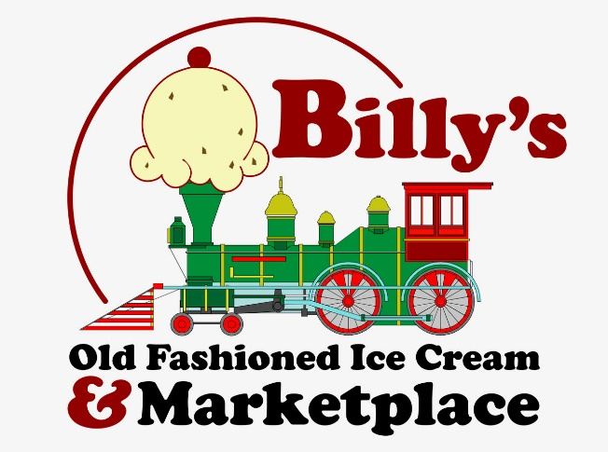

The Menu

Always Ask About Our Daily Specials

